TAASLP Day on the Hill 2019
Tuesday February 26, 2019
Agenda:
8:30-9:15 Orientation – John Williams, TAASLP Lobbyist
Discuss current legislative issues affecting profession/patients in SLP/AUD
9:15-12:00 Visits with Legislators as assigned
Advocate for current issues affecting AUDs/SLPs/our patients
12:00-12:30 Debriefing, Discuss legislator feedback – John Williams & Brittany Day

Learning outcomes- TAASLP’s Day on the Hill 2019
Participants will be able to:
1. To explain the procedure of introducing and moving a bill through the State legislature
2. To identify critical legislative issues for SLP/AuD practice in Tennessee
3. To advocate for their profession and patients by meeting with legislators

DISCLOSURES:
John Williams is contracted as a lobbyist for TAASLP and receives compensation for those activities. John Williams has no relevant non-financial relationships to disclose.

Brittany Day has no relevant financial or non-financial relationships to disclose.

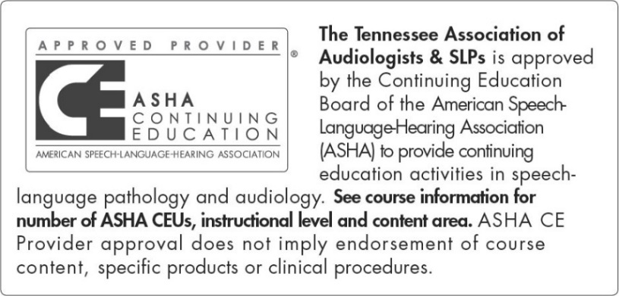
This program is offered for .40 ASHA CEUs (intermediate level, related area)

